# Module 10 – Creativity



## Module 10 objectives

At the end of this module, you will be able to…

* talk about how the brain influences the way we see the world.
* describe behavioral competencies necessary for a job interview.
* talk about your strengths and weaknesses in a job interview.
* give solutions to problems in English.
* talk about different problem solving methodologies.
* use appropriate body language in a job interview.
* talk about the creative process.
* describe a process.
* use your voice appropriately in interviews.
* discuss whether creativity should be taught at school or not.
* have a debate in English.
* give an example of a behavioral competency and structure your ideas.

# Lesson 1 – How our brain plays tricks on us



## Lesson 1 objectives

At the end of this lesson, you will be able to…

* talk about how the brain influences the way we see the world.
* describe behavioral competencies necessary for a job interview.
* talk about your strengths and weaknesses in a job interview.

## Activate

Discuss with a partner. Share your answers with the rest of the class.

* Do you know any optical illusions such as those in the image above?
* How do optical illusions work? What happens in your brain when you look at them?

## Learn

1. Work with a partner. Look at the following optical illusions. In each case, try to describe the optical illusion and try to figure out how the optical illusion works.

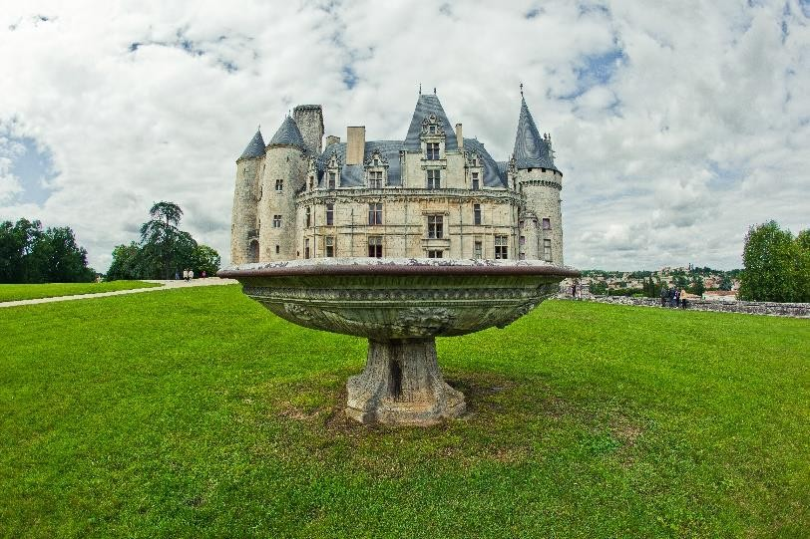





1. Read the magazine article about how our brain sees optical illusions. Find the explanations for the optical illusions in Activity 1.

### The neuroscience of optical illusions

Optical illusions come about because of the limitations in the physiology of eye and also because of the way the brain interprets the information sent to it by the eye. Our modern interest in optical illusions was born in the 19th century. However, our study of them goes back to the ancient Greeks. In the 21st century, neuroscientists have helped us make important advances in our understanding of how optical illusions work. A lot of this new information has come from technological advances in the 2000s, when neuroscientists were able to use functional magnetic resonance imaging (fMRI) to see what is happening in our brains when we look at something.

Scientists believe that we experience certain optical illusions because there is a slight delay (a tenth of a second) in what we see. In other words, what we see is always slightly in the past. Our brain compensates for this and it fills in the missing information coming from the eye. This means our brain is always interpreting what we see and giving us the most likely interpretation for what is in front of us. This can be useful for us as it helps us to predict what might happen in the future. For example, if we are crossing a street and a car suddenly appears from around a corner, this ability of the brain to interpret what is happening from information sent to it by the eye will allow us to react quickly and maybe even save our life.

Adjacent objects can also influence the way our brain interprets what we see. Our eyes give us two-dimensional representations of what is in front of us and the brain needs to convert this information into three-dimensional interpretations so we can understand what is in front of us. This is useful as it can give us a sense of distance. For example, a tall building such as the Empire State in New York can appear small if it is far away from us. This is known as perspective. However, our brain can sometimes misinterpret this information when two buildings are placed in front of each other. The building which is farther away will appear smaller than the one nearest to us, when in actual fact the two may be the same size or the one which is farther away may even be bigger. This makes it difficult for us to understand the true size or shape of what we are looking at.

Sometimes optical illusions are due to the physiology of the eye. When we look at something, our eyes make small, rapid movements called saccades. This was discovered by nineteenth-century German physician, Hermann von Helmholtz. To experience saccades, put a finger on your eye lid and move your eye. What you see will appear as snapshots. This may explain why some optical illusions appear to be moving for us. This movement is known as apparent motion. Susana Martínez Conde, a Spanish neuroscientist, believes that with every saccade the retinal image in refreshed and this sends a new image to the visual cortex each time the eye moves. If we stop the saccades, the brain adapts and the apparent motion stops.

Understanding how optical illusions work gives us a fascinating insight into the way our brains interpret what we see. It tells us that our brain’s creative interpretation of what we look at is not necessarily correct. Maybe we should question a little bit more what we see in order to move closer to the truth. And it shows us too just how powerful our brains are. So powerful that they can create things that are not really there.

## Do

1. Work with a partner. Find an optical illusion on the Internet. Describe it to another pair and explain how it works.

**Let’s use it!**

1. Work in a group of three. Discuss the following questions about the ideas in the text in Activity 2.

* + Does it surprise you that our brains cannot truly distinguish between reality and the imagination? Why?
  + What are the dangers of the fact that our brains work in this way?
  + What are the advantages for us of our brains working in this way?

1. Work in your groups. Create a short presentation of the ideas you discussed in Activity 6. Upload your presentation onto the class Wiki. Vote for the best presentation. Justify your votes.

|  |
| --- |
| **I am competent!**  **Interview skills part one – deciding which behavioral competencies you are good at**  Work with a partner. Look at the following list of behavioral competencies developed on your Generation English course. Can you talk about them? Refer back to the modules mentioned if necessary.   * Language learning strategies (Module 1) * Working in a team (Module 2) * Persistence/not giving up (Module 3) * Attention to detail (Module 4) * Achieving difficult goals (Module 5) * Time management (Module 6) * Planning (Module 7) * Participating in a forum (Module 8) * Giving a presentation (Module 9)     Which of the competencies in the list are you good at and which do you need to work on?  What are you going to say in your job interview about what you can/cannot do as a  professional? (TIP: It is normal for people to have areas of opportunity with certain behavioral competencies. The important thing is to show what you are doing to improve on your weaknesses. Are you taking a course? Are you practicing the competency in your job? Are you being coached by your boss on the competency you are weak on?) |

**How did I do? Evaluate yourself.**

|  |  |  |  |  |
| --- | --- | --- | --- | --- |
|  | **I can’t yet…** ☹ | **More or less (-)** | **Yes, I can!** 😊 | **If you need help, go to…** |
| I can talk about how the brain influences the way we see the world. |  |  |  | Activities 2, 3, 4 and 5 |
| I can describe behavioral competencies necessary for a job interview. |  |  |  | I am competent! |
| I can talk about your strengths and weaknesses in a job interview. |  |  |  | I am competent! |

# Lesson 2 – Using creativity to solve problems



## Lesson 2 objectives

At the end of this lesson, you will be able to…

* give solutions to problems in English.
* talk about different problem solving methodologies.
* use appropriate body language in a job interview.

## Activate

Discuss with a partner. Share your answers with the rest of the class.

* How can being creative help us to solve problems?
* Can you remember a time when you used your creativity to solve a problem? What did you do?

## Learn

1. Work in a group of three. Read the following case study and decide how you would solve the problem. Use the language in the box to talk about your solution.

I think they should…

In my opinion,…

One possible solution might be to…

There are a few different things they could do. For example,…

They shouldn’t…

I wonder if they tried to…

They could try to…

If I were them, I would…

Mayra, Juan, Luis and Olivia are Java programmers in a small tech company called DigiSolutions. The company has won a big project with a bank to redesign its customer-facing Web site. The interface the customer uses is the area that the bank needs most help with, as there have been thousands of complaints that it is difficult to use. The project has run into problems because the programming team were unrealistic in their planning. They thought that they would be able to produce the code needed to give the client the agreed functionality faster. The project is now two weeks behind schedule. To make matters worse, Olivia has started to blame Juan for the problem. She claims that he does not work fast enough and that he is slowing down the whole team. Juan has retaliated criticizing Olivia’s planning skills. Olivia is the project leader and producing a robust plan was a key responsibility of hers. The atmosphere in the daily team update meetings is tense. Olivia and Juan have almost refused to speak to each other. When they do speak, it is to criticize each other and this makes Mayra and Luis feel very uncomfortable. Meanwhile, the clock is ticking and the project is falling further behind schedule because the team cannot reach agreement on how to proceed. The bank has threatened to sue DigiSolutions if they

do not start to deliver according the agreed dates. If you were part of this programming team, what would you do to solve the problem?

2. Discuss with a partner. Which language from the box in Activity 1 did you find most useful? Write it down in your portfolio.

## Do

1. Work individually. Write down in your portfolio a problem you are facing right now.

1. Work with a partner. Tell each other about your problems. Use the language for solving problems that you learned in Activities 1 and 2 to offer each other solutions. Share the most interesting solutions as a class.

**Let’s use it!**

1. Work with a partner. Investigate the following methodologies for problem solving online. Choose one of them and write a short one-minute presentation about how it works.

* + The Deming-Shewart Cycle
  + Kepner-Tregoe Decision Analysis
  + Lean Six Sigma
  + Kaizen
  + The Eight Discipline (8D) methodology
  + Appreciative Enquiry

1. Work with a partner. Create a presentation with voice over about the methodology you chose. Upload the presentation onto the class Wiki. Vote for the best presentation. Justify your vote.

|  |
| --- |
| **I am competent!**  **Interview skills part two – body language**  Work with a partner. Which of the following body language is appropriate for an interviewee in a job interview? Justify your answers.   * Slumping in your chair * Slouching over the table * Head tilted slightly to one side * Head down, looking up at the interviewer * Arms crossed * Arms on the table, leaning slightly forward * Maintaining eye contact * Shifty eyes * Chewing gum * Fidgeting     Act out with a partner the body language you should use when you go for a job interview, |

**How did I do? Evaluate yourself.**

|  |  |  |  |  |
| --- | --- | --- | --- | --- |
|  | **I can’t yet…** ☹ | **More or less (-)** | **Yes, I can!** 😊 | **If you need help, go to…** |
| I can give solutions to problems in English. |  |  |  | Activities 1 to 4 |
| I can talk about different problem solving methodologies. |  |  |  | Activities 5 & 6. |
| I can use appropriate body language in a job interview. |  |  |  | I am competent! |

# Lesson 3 – Famous creative people

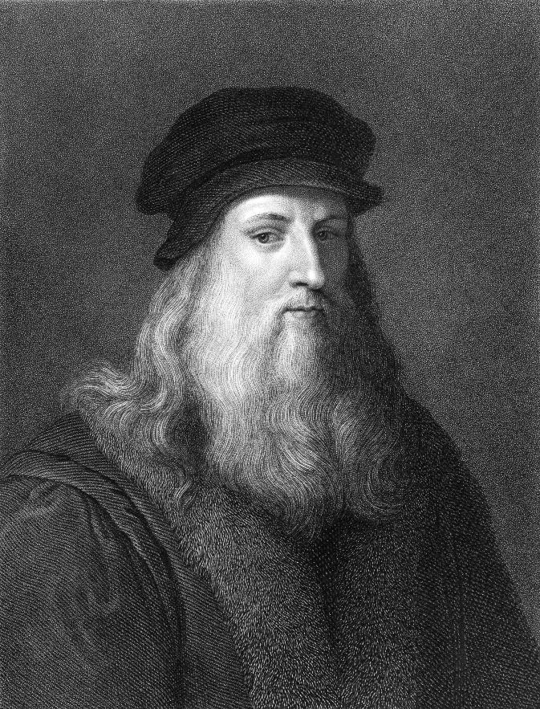

## Lesson 3 objectives

At the end of this lesson, you will be able to…

* talk about the creative process.
* describe a process.
* use your voice appropriately in interviews.

## Activate

Work with a partner. Discuss the following questions.

* Who is the person in the image? Why is he famous? In what ways was he creative?
* What other famous creative people can you identify?
* Why are they famous?

## Learn

1. Work with a partner. Match the names of the famous creative people to the images on page 15. Use the Internet to investigate if you wish. Justify your choices.

* + Steve Jobs
  + Lady Gaga
  + Pineda Covalin
  + Frida Kahlo
  + Celia Cruz

1. Work with a partner. Listen to songwriter John Diamond talking about his creative process. Map this process using the flow chart below.

Experimentation

stage (go for a walk,

play the guitar etc.)

1. Work with a partner. Read Audio script 10.1. Underline the words and phrases that John Diamond uses to describe his creative process.

## Do

1. Work with a partner. Use the vocabulary from Activity 3 to describe the process in the following diagram. Write your description in your portfolio.

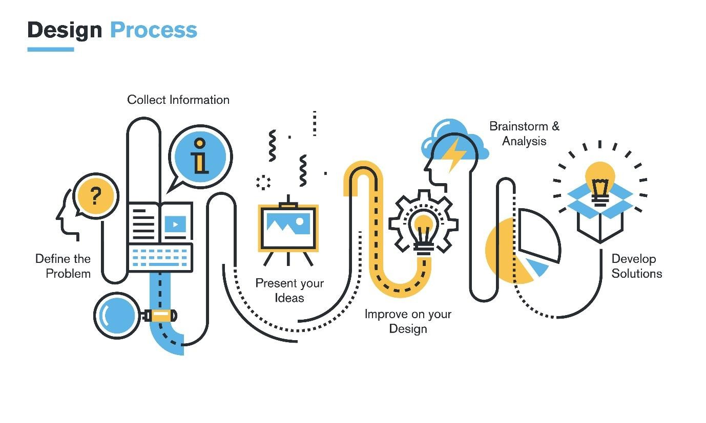

**Let’s use it!**

1. Work in groups. Investigate the different processes used by people who need creativity for their jobs. Some examples might be painters, advertising executives, writers or film makers.

1. In your group, create a presentation with the information you find.

1. Record a narration for your presentation and upload it onto the class Wiki. Vote for the best presentation. Justify your vote.



|  |
| --- |
| **I am competent!**  **Interview skills part 3 – using your voice appropriately**  Which of the following ways of using your voice is appropriate in an interview?   * Shouting o Speaking softly * Stressing the key words in what you say * Using rising intonation on the key words in what you say o Sarcastic tone of voice o Enthusiastic tone of voice o Kind tone of voice     Work with a partner. Practice talking about yourselves with an appropriate use of voice.  Talk about the following things:   * The behavioral competencies you are good at * The behavioral competencies you need to work on and what you are doing to improve * What you learned about Java on your Generation course |

**How did I do? Evaluate yourself.**

|  |  |  |  |  |
| --- | --- | --- | --- | --- |
|  | **I can’t yet…** ☹ | **More or less (-)** | **Yes, I can!** 😊 | **If you need help, go to…** |
| I can talk about the creative process. |  |  |  | Activities 1, 2, 5, 6 & 7 |
| I can describe a process. |  |  |  | Activities 3 & 4 |
| I can use my voice appropriately in interviews. |  |  |  | I am competent! |

# Lesson 4 – Teaching creativity



## Lesson 4 objectives

At the end of this lesson, you will be able to…

* discuss whether creativity should be taught at school or not.
* have a debate in English.
* give an example of a behavioral competency and structure your ideas.

## Activate

Discuss the following questions with a partner.

* What is the child in the photo learning to do?
* Should creativity be taught at school? Why/why not?
* Is creativity something that can be taught or are you just born with it?

## Learn

1. Work with a partner. Listen to a university lecturer talking about why creativity should be taught at school. Do you agree with his opinion?

1. Work with a partner. Read the following opinions on whether creativity should be taught in school. Which one is closest to your own?

### Opinion A

I think that people should learn practical things at school. This means there should be a focus on mathematics, computer skills, language skills and literacy. The purpose of education is to prepare people for the world of work.

### Opinion B

I believe that education is about developing the whole person. Its function is to prepare people for life and its challenges, not only for the world of work. People need to be wellrounded emotionally, intellectually, and physically. Our education systems should be helping them achieve this.

### Opinion C

In my opinion, education is primarily to help people get ready for the world of work. However, we should teach students other disciplines so that they can be well-rounded individuals. Some time should be allocated on the school curriculum to creative subjects.

### Opinion D

In my opinion, education is primarily to help people get ready for life. However, we should teach students subjects that help them get ready for the world of work. The curriculum should focus on giving people a balanced education. However, some time should be allocated on the school curriculum to practical subjects such as accountancy, applied mathematics and communication skills.

3. Work with a partner. Look at the phrases marked in red in the Audio script 10.2 and Opinions A to D above. What is the function of the phrases? (What do we use them for?)

## Do

1. Work with a partner. Make sentences about the following topics using the language you identified in Activity 3.

* + - Should private education be banned and all education made public?
    - Which is more important a job that gives you lots of money or a job which gives you lots of free time?
    - Should health care be public or private?
    - Will robots taking over menial jobs free us to do work where we use our brain power?
    - A controversial topic of your own

* 1. _____________________________________________________
  2. _____________________________________________________
  3. _____________________________________________________
  4. _____________________________________________________
  5. _____________________________________________________

**Let’s use it!**

1. Work in groups. You are going to have a debate. Choose one of the topics from

Activity 4.

1. In your groups, debate the topic. Make sure to use the language you learned in Activity 3.

1. When you have finished debating, share the results of what you discuss with the rest of the class. Vote as a class on the most interesting discussion.

**I am competent!**

**Interview skills part 4 – giving an example of how you put a competency into practice and sequencing your ideas**

In job interviews, you will often be asked to give a concrete example of how you have used one of the essential work competencies.

Work with a partner. Read the following example given by an interviewee of how they have used a behavioural competency. Which competency are they talking about? Underline the words and phrases they use to sequence their ideas.

“Well, once I was working on a project where we needed to put in a new floor in a building and the truck scheduled to deliver the material phoned to cancel. They said they couldn’t make it that day. So, instead of losing a day’s work, I organized the people working with me who had cars and some of my friends, to go and pick up the building material from the hardware store. That way, we started working on the floor that day and we finished on time.”

Work individually. Choose one of the competencies listed in the I am competent box in Lesson 1. In your portfolio, write an example of how you have used that competency. Be sure to use the sequencing language from the example. Share what you have written with a partner. Give each other advice on how to improve your examples.

**How did I do? Evaluate yourself.**

|  |  |  |  |  |
| --- | --- | --- | --- | --- |
|  | **I can’t yet…** ☹ | **More or less (-)** | **Yes, I can!** 😊 | **If you need help, go to…** |
| I can discuss whether creativity should be taught at school or not. |  |  |  | Activate,  Activities 1 & 2 |
| I can have a debate in English. |  |  |  | Activities 3 to 7 |
| I can give an example of a behavioral competency and structure my ideas. |  |  |  | I am competent! |

# Lesson 5 Product lesson – a job interview



In this module, we learned how to give an effective interview in English. In this product lesson, you are going to role play an interview using the role cards at the end of the module. Before you prepare for your interview, let’s remind ourselves of what the essential ingredients of a job interview are. Try answering the following quiz with a partner. Go back to the I am competent boxes in lessons 1 to 4 to check your answers.

1. What are the behavioral competencies that you have learned to talk about on your Generation English course?
2. Choose one behavioral competency and talk about it.
3. What advice would you give to someone preparing for an interview on the body language they should use in an interview?
4. What advice would you give to someone on how they should use their voice in an interview?
5. Give an example of how you have put a behavioral competency into practice.

Work in groups of three. Choose a role card from the end of the module. Read it carefully. Note down on your role card the language you will use during the role play.

Practice your role play in your group of three.

Video yourselves role playing your interview.

Upload your videos onto the class Wiki. Vote as a class for the most effective interview. Justify your vote.

**I can learn**

**!**

What di

d you learn from this lesson?

Write your ideas in your portfolio. Compare what you write with a partner. Discuss what you

read in each other’s portfolios.



## Evaluate the product lesson

|  |  |  |  |  |
| --- | --- | --- | --- | --- |
|  | **Could be better** ☹ | **More or less**  **(-)** | **Yes, we did it!**  😊 | **What we can do next time to improve** |
| My partners and I worked well as a team. |  |  |  |  |
| Our product was interesting for the rest of the class. |  |  |  |  |
| We learned something that we can apply to our real lives. |  |  |  |  |
| We were able to reflect on what happened during the class. |  |  |  |  |

### Student A

You are interviewing a candidate (Student C) for the job of Java programmer at your company, DigiSolutions. Student B will be interviewing the client with you, but they will not ask questions. Rather, Student B will be evaluating the candidate’s performance. Write the questions you will ask the candidate in the box below.

|  |
| --- |
|  |

### Student B

Along with Student A, you are interviewing the candidate (Student C) for the job of Java programmer at DigiSolutions. You will not ask questions. Rather, you will listen to the candidate and evaluate their performance. Write down in the box below, the criteria you will use to evaluate the candidate’s performance.

|  |
| --- |
|  |

### Student C

You are a candidate for the job of Java programmer at DigiSolutions. Student A will be interviewing you with questions and Student B will be evaluating your performance. Write down notes about what you will say in the interview in the box below.

|  |
| --- |
|  |

### Audio scripts

[Audio script 10.1]

I write songs for international artists. I don’t actually perform the songs. I sell them to music publishers and they record them with their artists. I’ve written some pretty famous hits. I bet you’ve heard some of them on the radio.

The thing about my job is that I need to deliver on a regular basis to the music publishers. So, I need to be writing every day. I have to meet those deadlines: whether I’m feeling creative or not!

I divide my creative process into two major stages. Firstly, I work with experimentation; you know, the actual creation of the music and words. Then I need to edit and evaluate what I’ve produced.

I find that my thought processes are different in the two stages. In the experimentation stage, I find it useful to go for a walk and think about what I need to create or just pick up my guitar and play. This is a kind of day-dreaming. When I’m in that state, I have my best ideas. Sometimes, I even have my best ideas in the shower! The important thing is not to pay too much attention to what I’m doing. I then record the music with my guitar or keyboard. I might record some lyrics too. Or sometimes I write those down on paper.

Then, once I have a preliminary recording of the music and maybe some lyrics, I start editing. I pay attention to what I’ve written down on paper and I start to polish it to produce what I deliver to the music publisher. I normally re-record my preliminary recordings, paying a lot of attention to the quality of the recording. For example, I need to use the right microphones and I spend hours listening back and making adjustments to the recording.

Once I have the final recording, I put it through a mastering process. In mastering, you clean the recording and you make sure the bass and treble levels are not too high or too low. A mastered recording should sound great anywhere: on the radio or on a tiny speaker on your phone. In the end of the day, my recording isn’t the one used by the publishing house as it’s their artists who will record the song, but I need to deliver a high-quality recording so that my client can understand what the final recording might sound like.

[Audio script 10.2]

Good afternoon, everyone! Today’s lecture is on the teaching of creativity at school. I will talk about what has happened to education and why we should be teaching creativity. I will also talk about some ways we can do this.

Now, if we look around the world at the different education systems, we can see that mathematics and languages are prioritized. They are given the most number of hours on the school curriculum. The arts, on the other hand, are the subjects that we don’t teach at school. This is because we think they aren’t useful. The focus of our education systems is on teaching students what we think will be useful for them to get a job.

The fact is that we don’t know what jobs people will be doing in the future. We think that teaching subjects which involve our brains will guarantee these students a job in the future; when in actual fact, levels of unemployment among people holding university degrees is higher than ever. Our future is unpredictable. Our education systems are preparing people for jobs that don’t even exist yet. So, how can we know what subjects will be useful to them?

I argue that we should be educating people based on what they like and what they are good at. This way we can ensure that we develop their talents and our education systems will produce a diverse range of different kinds of people. This way we can guarantee that we are preparing our students for the reality of the future.

And how can we do this? The answer is simple. We teach mathematics every day. Why can’t we teach dance every day? Why is dance not as important as mathematics? We need to be developing the whole person. To do this, we must allocate equal amounts of time in the school curriculum to disciplines that involve our bodies, our minds and our emotions.